CO2 injection system:
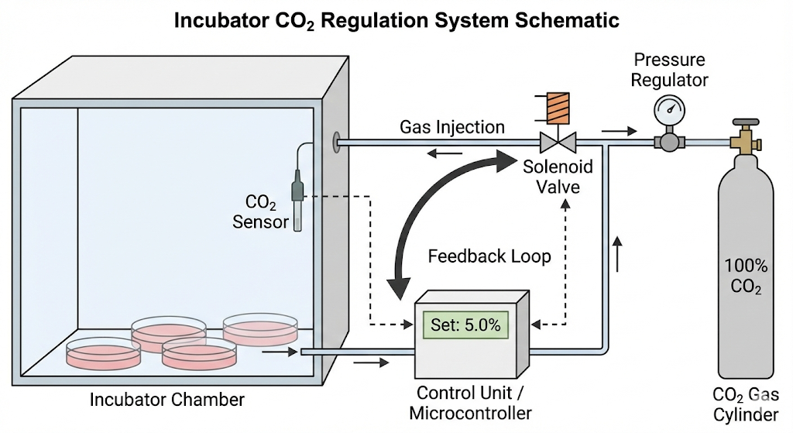
An important addition to be recommended for the incubator is a CO2 injection system. This is because most of the culture media contain sodium bicarbonate, which is a base. The CO2 reacts with the water, which forms carbonic acid. This neutralizes the media. Otherwise, the system would lose acidity, and the cells would eventually die in the long term. The CO2 injection system consists of an IR sensor that detects the CO2 levels in the incubator, and when it drops below 5%, it opens a solenoid valve that’s connected to a CO2 gas cylinder, puffing the gas into the incubator. This system is presented in the following Figure. We unfortunately couldn’t apply such a system in our prototype, since, without a license, we are not allowed to have a CO2 container for safety reasons.

Water jacket insulation system:
The most important section in the incubator is the insulation system, since poor insulation would lead to huge amounts of heat losses, which would put the heaters under a higher load just to reach the desired temperature. For instance, if the heaters worked regularly, they would need to be active every 3 minutes; poor insulation would drastically increase that to once every minute. This also has a higher risk of killing the cells, since if the walls get too cold, water droplets will start to build up on the walls and the ceiling, and if a droplet falls on the petri dish, this instantly contaminates and kills the cells. We can use the water jacket insulation system to insulate the incubator, which works by double-layering the walls and pouring warm water in between. Water has high heat capacity, which is why it’s a good insulator, and it also matches our requirement of the project being environmentally friendly. We instead used passive foam, since the water jacket requires stainless steel, which is hard to find in old devices.

stainless steel & copper lining:
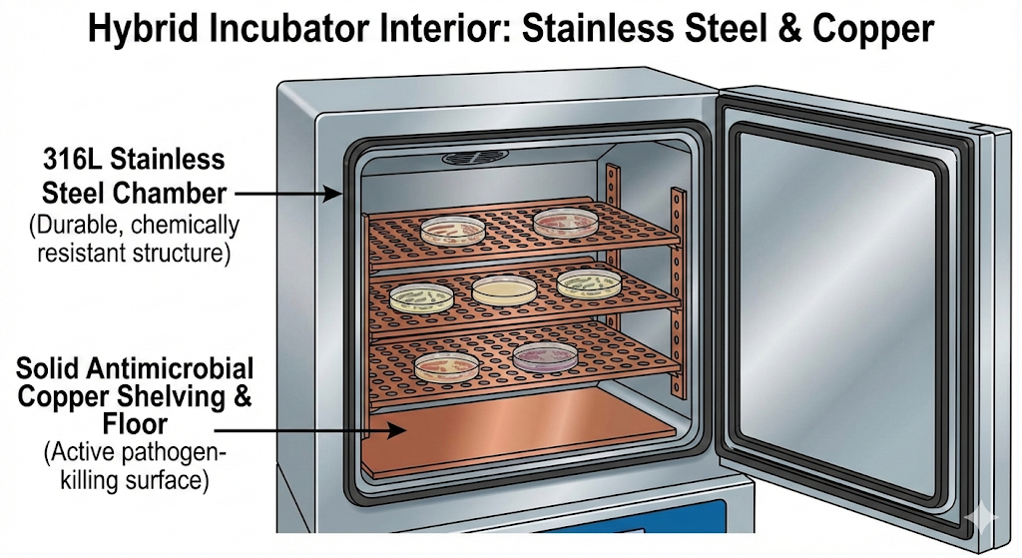
it’s recommended to double-layer the body of the incubator, where it’s best to use stainless steel for the outer shell, which has high chemical resistance, preventing rusting. However, for the inner chamber and racks, it’s recommended to use copper lining as the main material, as shown in the figure. Biofilm has a high risk of cross-contamination between the bacteria, where the bacteria produce an extracellular matrix that sticks to surfaces, and rough surfaces like wood or plastic are easier to stick to. To prevent biofilm, the best way is to use copper lining. This totally prevents any leakage of bacteria outside the petri dish. That’s because copper lining is oligodynamic, which means that it instantly kills any bacteria that touch it. This is crucial, since the one thing that shouldn’t happen in a laboratory is contamination in/outside the incubators, which can cause catastrophic disease spreads. This wasn’t applied in the prototype because copper lining costs too much, reaching 11 USD per kg.

